Exercise 1: Implementing the Singleton Pattern
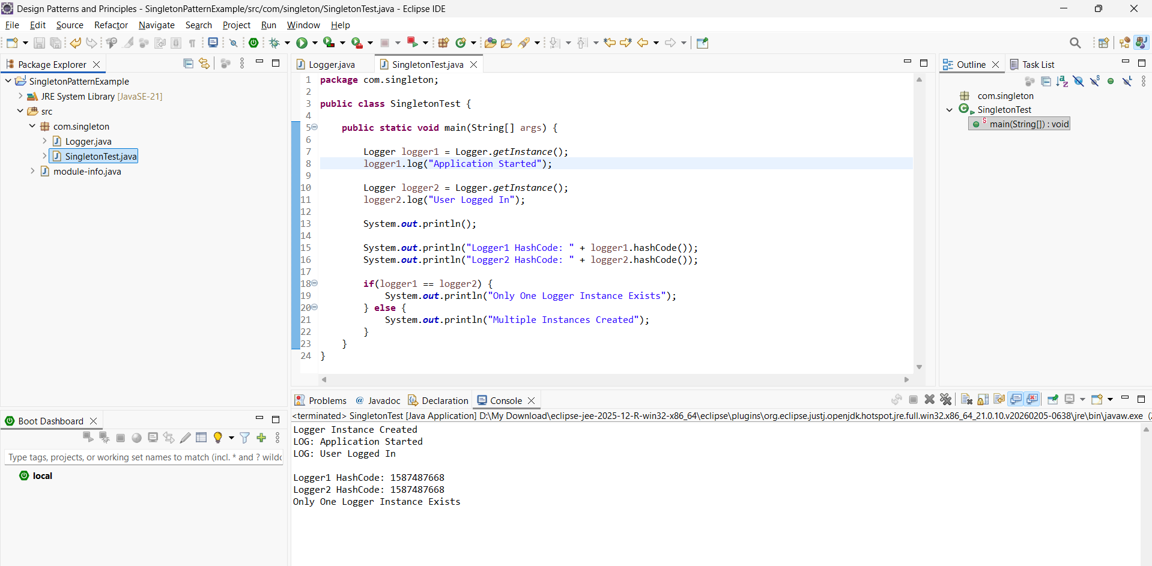
Exercise 2: Implementing the Factory Method Pattern
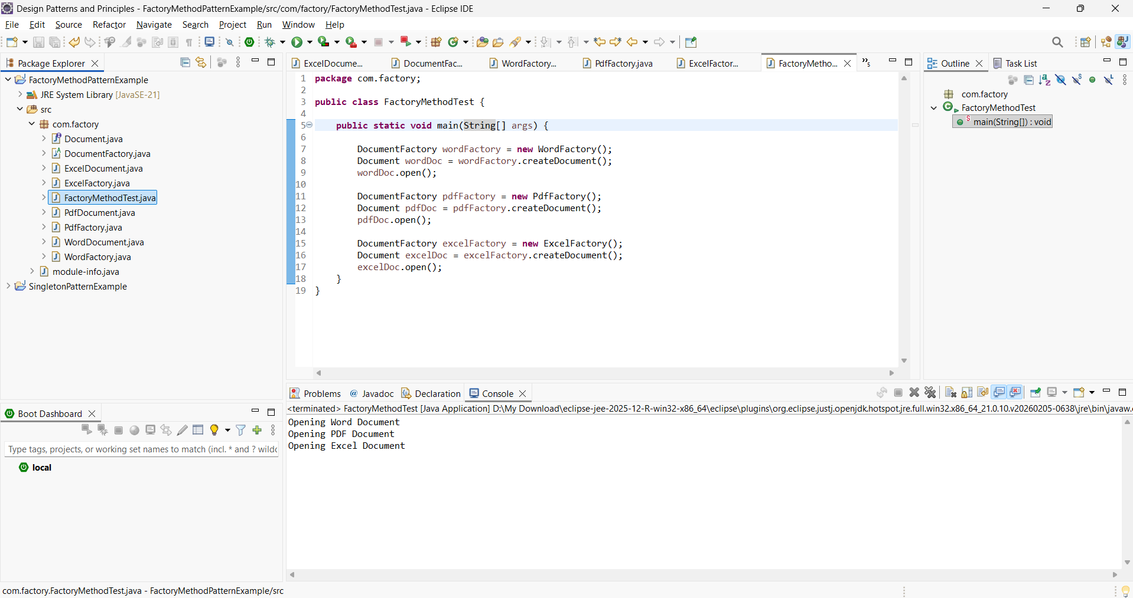
Exercise 3: Implementing the Builder Pattern
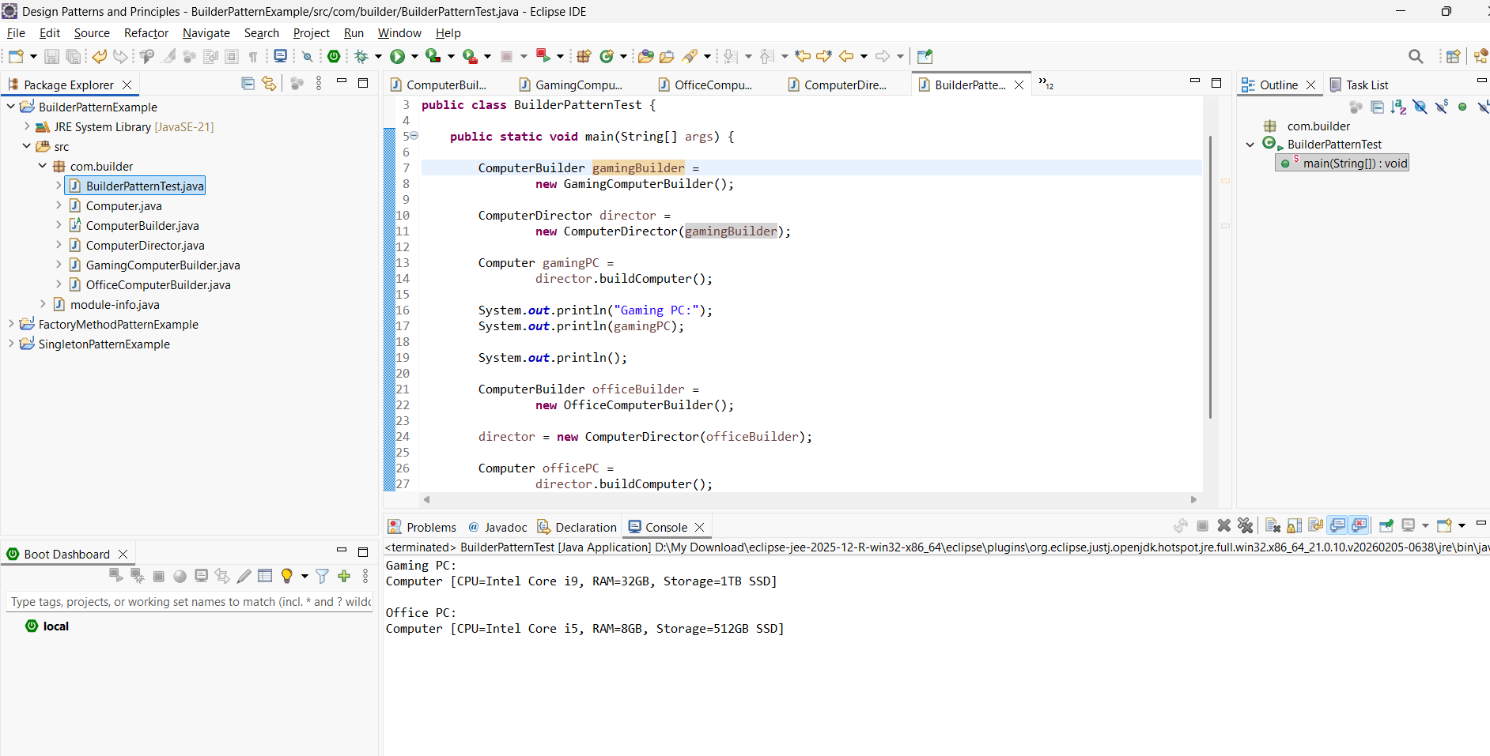
Exercise 4: Implementing the Adapter Pattern
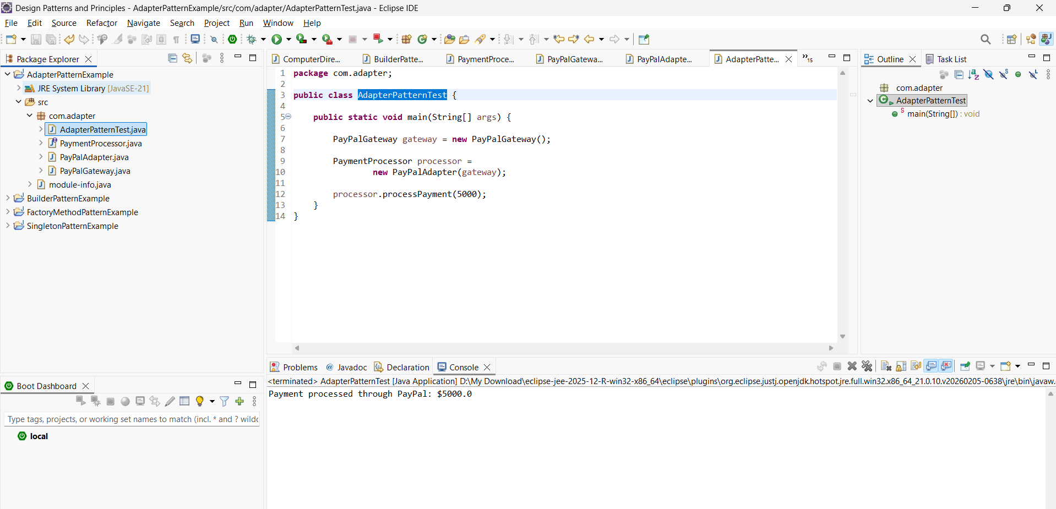

Exercise 5: Implementing the Decorator Pattern
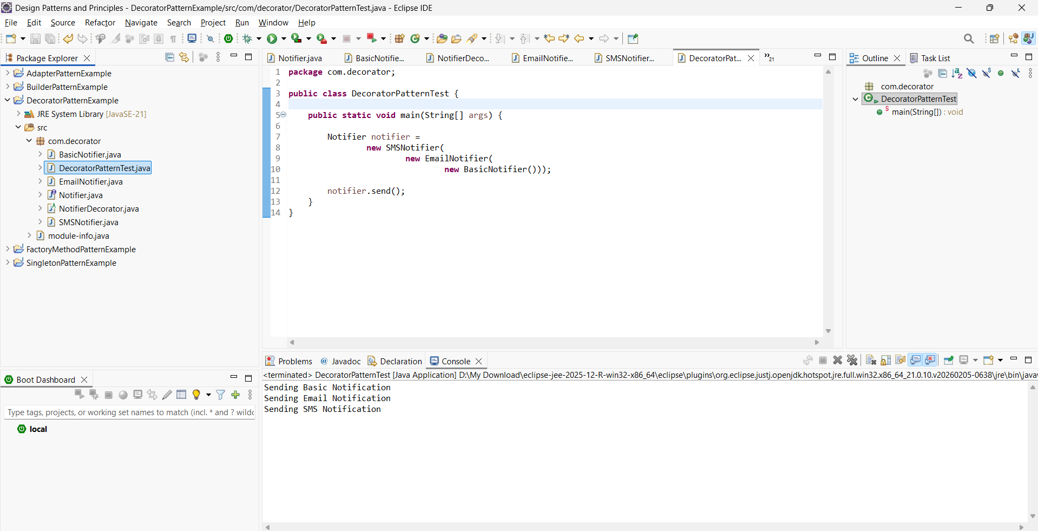
Exercise 6: Implementing the Proxy Pattern
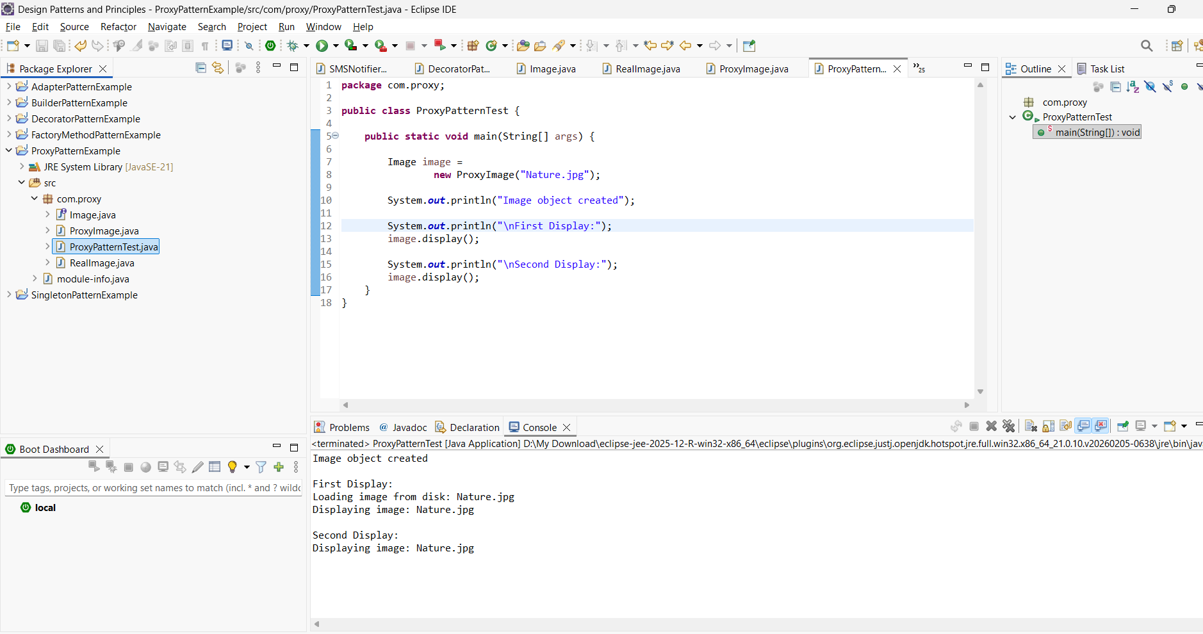
Exercise 7: Implementing the Observer Pattern
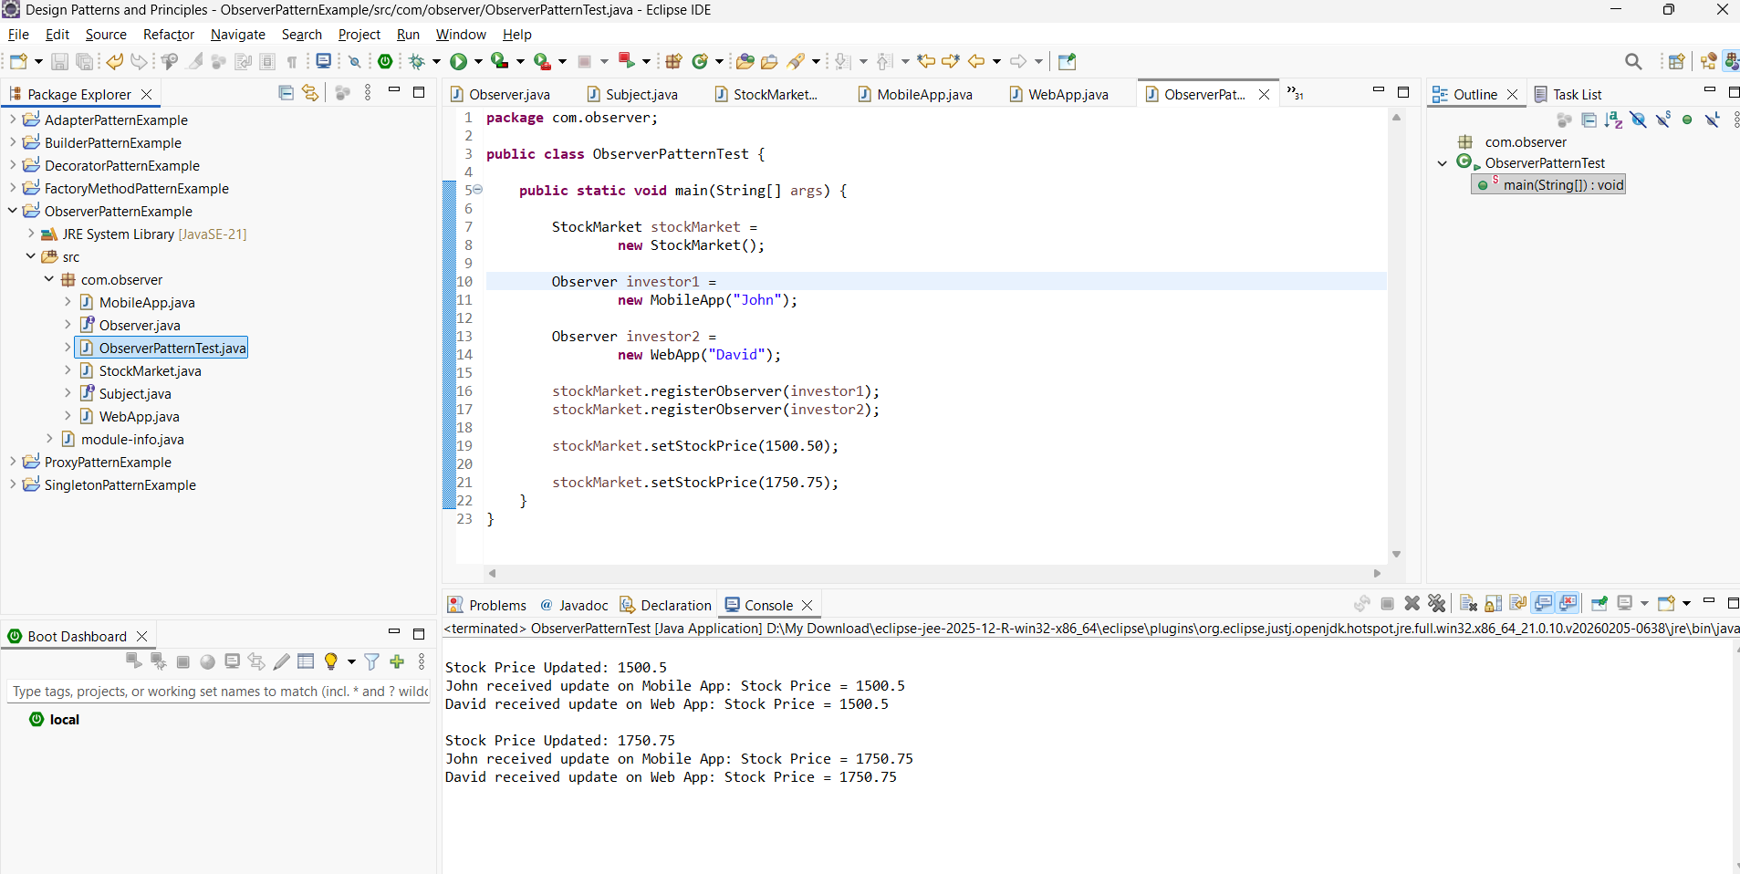
Exercise 8: Implementing the Strategy Pattern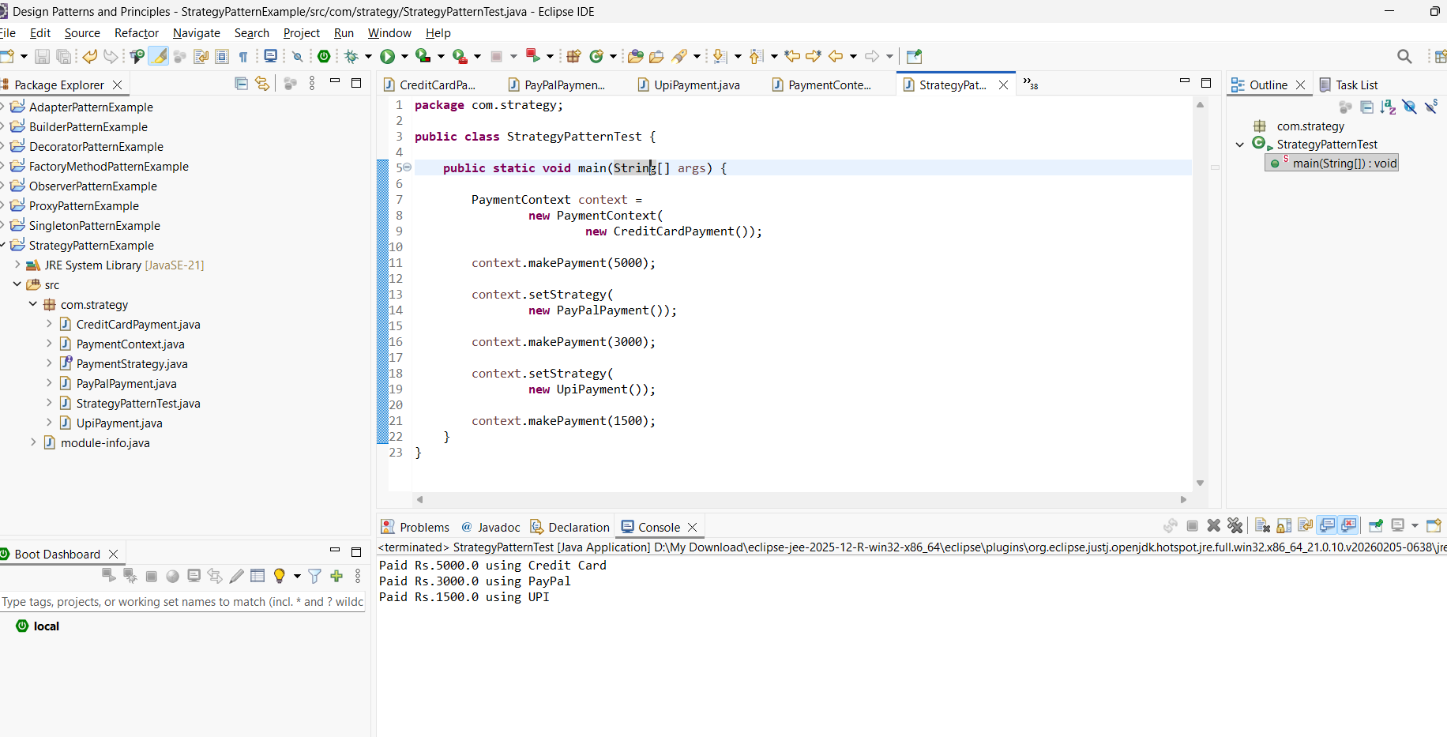

Exercise 9: Implementing the Command Pattern
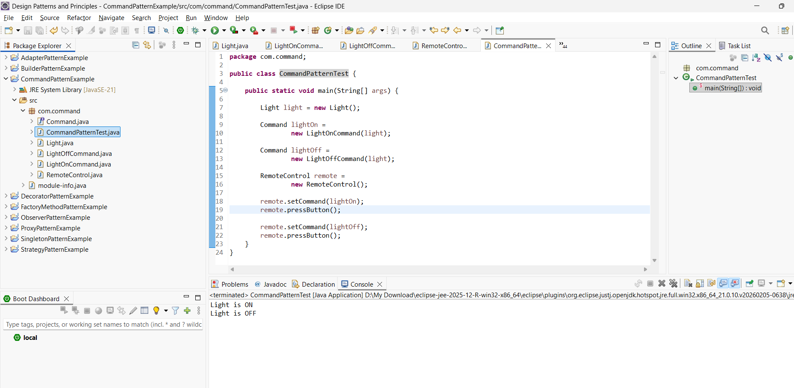
Exercise 10: Implementing the MVC Pattern
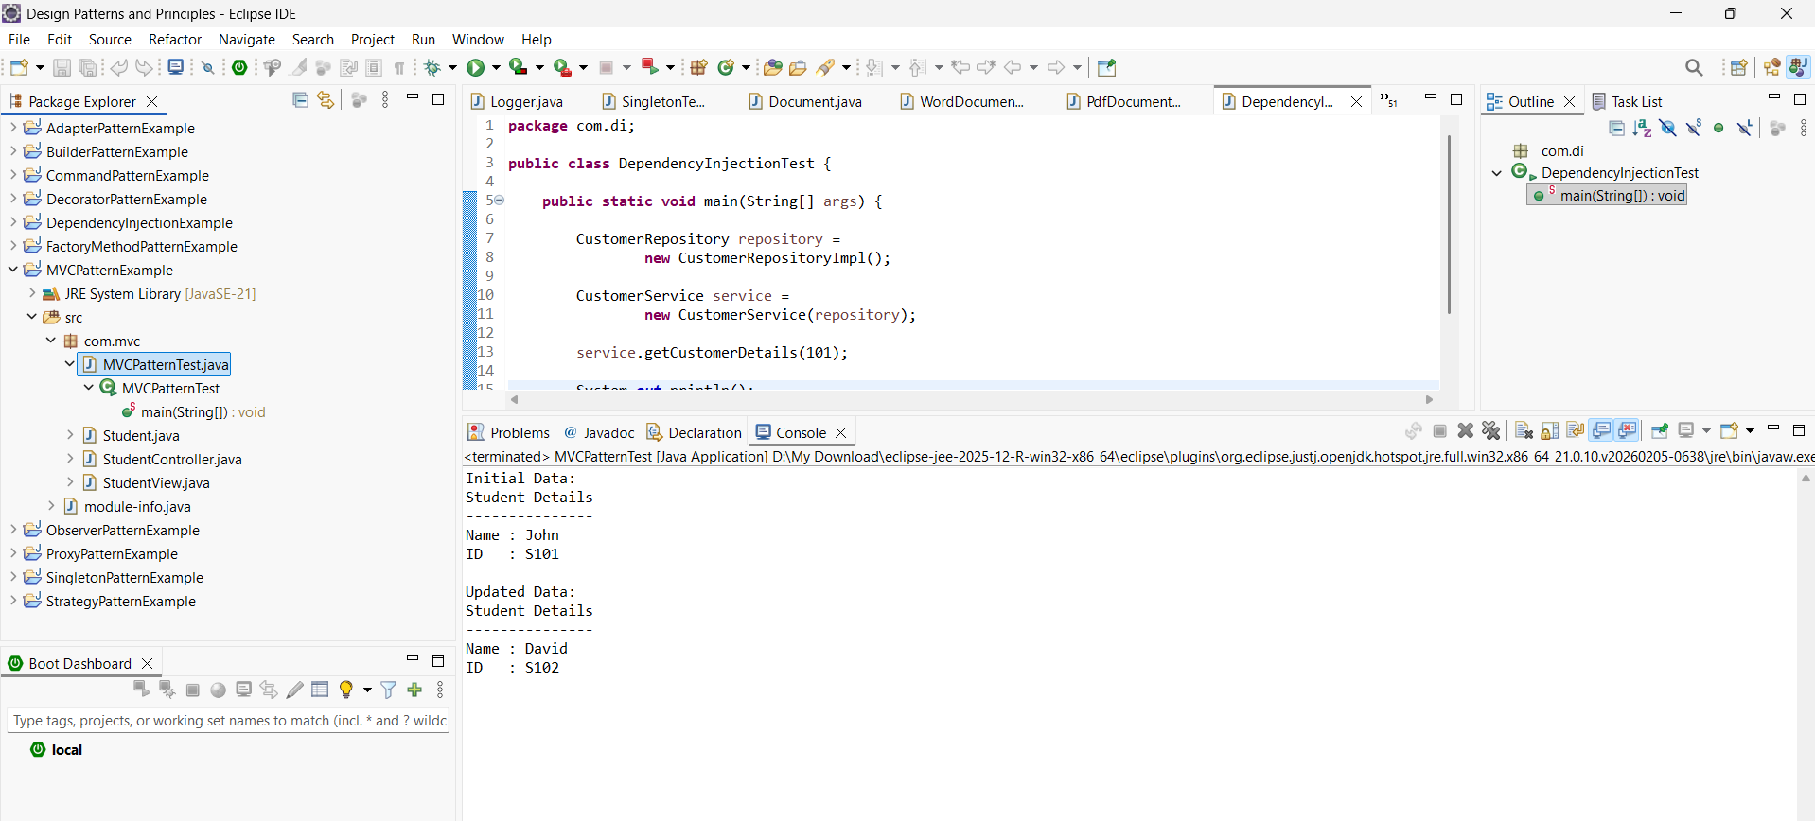

Exercise 11: Implementing Dependency Injection
